[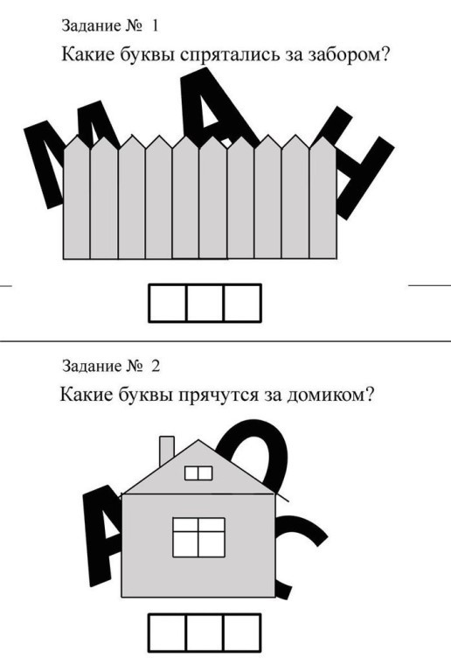](https://ok.ru/dk?cmd=PopLayerPhoto&st.layer.cmd=PopLayerPhotoOuter&st.layer.type=GROUP&st.layer.revNav=off&st.layer.limitedUi=false&st.layer.closeLayers=off&st.layer.sphotoIds=864367573509;864367573765;864367574021;864367574277;864367574533;864367574789;864367575045;864367575301;864367575557;864367575813&st.layer.showNav=on&st.layer.photoAlbumId=53823353978885&st.layer.epm=off&st.layer.photoId=864367573509&st.layer.opl=off&st.layer.navStartPhotoId=864367573509&st.layer.sbd=off&st.cmd=userMain&st._aid=GroupTopicLayer_openPhotoLayer) [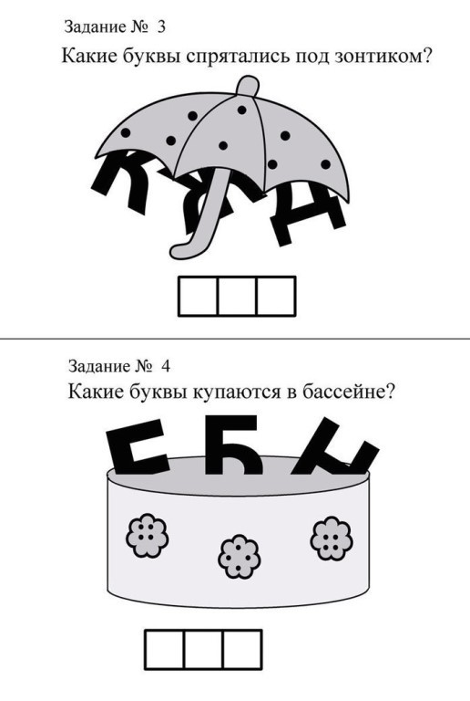](https://ok.ru/dk?cmd=PopLayerPhoto&st.layer.cmd=PopLayerPhotoOuter&st.layer.type=GROUP&st.layer.revNav=off&st.layer.limitedUi=false&st.layer.closeLayers=off&st.layer.sphotoIds=864367573509;864367573765;864367574021;864367574277;864367574533;864367574789;864367575045;864367575301;864367575557;864367575813&st.layer.showNav=on&st.layer.photoAlbumId=53823353978885&st.layer.epm=off&st.layer.photoId=864367573765&st.layer.opl=off&st.layer.navStartPhotoId=864367573765&st.layer.sbd=off&st.cmd=userMain&st._aid=GroupTopicLayer_openPhotoLayer)[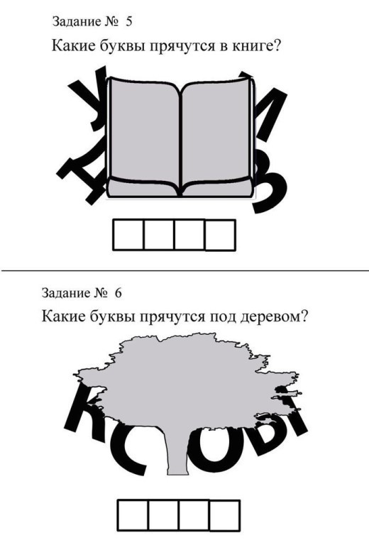](https://ok.ru/dk?cmd=PopLayerPhoto&st.layer.cmd=PopLayerPhotoOuter&st.layer.type=GROUP&st.layer.revNav=off&st.layer.limitedUi=false&st.layer.closeLayers=off&st.layer.sphotoIds=864367573509;864367573765;864367574021;864367574277;864367574533;864367574789;864367575045;864367575301;864367575557;864367575813&st.layer.showNav=on&st.layer.photoAlbumId=53823353978885&st.layer.epm=off&st.layer.photoId=864367574021&st.layer.opl=off&st.layer.navStartPhotoId=864367574021&st.layer.sbd=off&st.cmd=userMain&st._aid=GroupTopicLayer_openPhotoLayer) [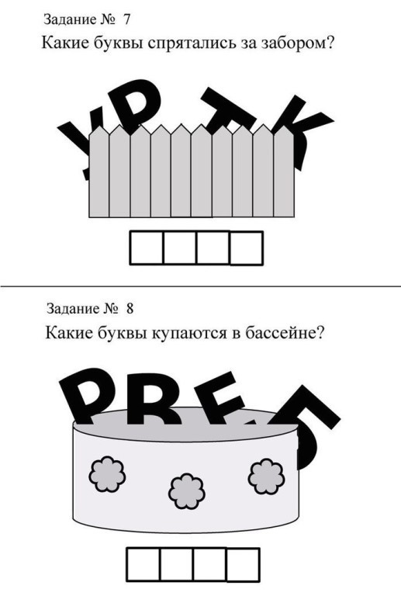](https://ok.ru/dk?cmd=PopLayerPhoto&st.layer.cmd=PopLayerPhotoOuter&st.layer.type=GROUP&st.layer.revNav=off&st.layer.limitedUi=false&st.layer.closeLayers=off&st.layer.sphotoIds=864367573509;864367573765;864367574021;864367574277;864367574533;864367574789;864367575045;864367575301;864367575557;864367575813&st.layer.showNav=on&st.layer.photoAlbumId=53823353978885&st.layer.epm=off&st.layer.photoId=864367574277&st.layer.opl=off&st.layer.navStartPhotoId=864367574277&st.layer.sbd=off&st.cmd=userMain&st._aid=GroupTopicLayer_openPhotoLayer)

[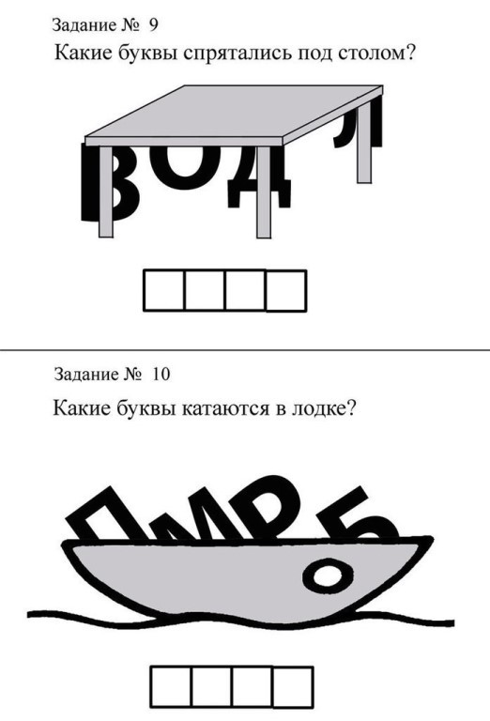](https://ok.ru/dk?cmd=PopLayerPhoto&st.layer.cmd=PopLayerPhotoOuter&st.layer.type=GROUP&st.layer.revNav=off&st.layer.limitedUi=false&st.layer.closeLayers=off&st.layer.sphotoIds=864367573509;864367573765;864367574021;864367574277;864367574533;864367574789;864367575045;864367575301;864367575557;864367575813&st.layer.showNav=on&st.layer.photoAlbumId=53823353978885&st.layer.epm=off&st.layer.photoId=864367574533&st.layer.opl=off&st.layer.navStartPhotoId=864367574533&st.layer.sbd=off&st.cmd=userMain&st._aid=GroupTopicLayer_openPhotoLayer) [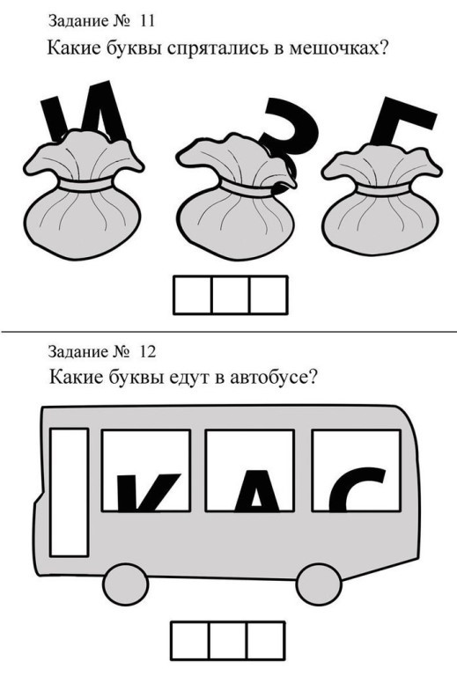](https://ok.ru/dk?cmd=PopLayerPhoto&st.layer.cmd=PopLayerPhotoOuter&st.layer.type=GROUP&st.layer.revNav=off&st.layer.limitedUi=false&st.layer.closeLayers=off&st.layer.sphotoIds=864367573509;864367573765;864367574021;864367574277;864367574533;864367574789;864367575045;864367575301;864367575557;864367575813&st.layer.showNav=on&st.layer.photoAlbumId=53823353978885&st.layer.epm=off&st.layer.photoId=864367574789&st.layer.opl=off&st.layer.navStartPhotoId=864367574789&st.layer.sbd=off&st.cmd=userMain&st._aid=GroupTopicLayer_openPhotoLayer)

[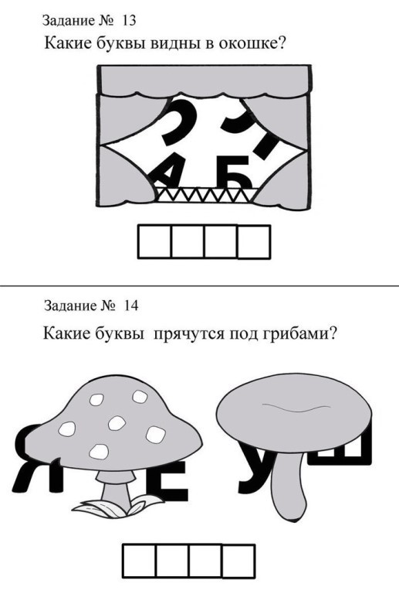](https://ok.ru/dk?cmd=PopLayerPhoto&st.layer.cmd=PopLayerPhotoOuter&st.layer.type=GROUP&st.layer.revNav=off&st.layer.limitedUi=false&st.layer.closeLayers=off&st.layer.sphotoIds=864367573509;864367573765;864367574021;864367574277;864367574533;864367574789;864367575045;864367575301;864367575557;864367575813&st.layer.showNav=on&st.layer.photoAlbumId=53823353978885&st.layer.epm=off&st.layer.photoId=864367575045&st.layer.opl=off&st.layer.navStartPhotoId=864367575045&st.layer.sbd=off&st.cmd=userMain&st._aid=GroupTopicLayer_openPhotoLayer) [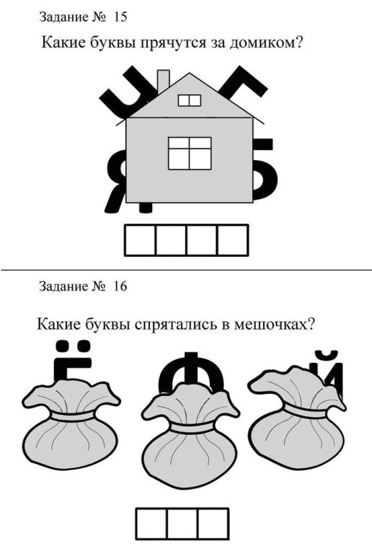](https://ok.ru/dk?cmd=PopLayerPhoto&st.layer.cmd=PopLayerPhotoOuter&st.layer.type=GROUP&st.layer.revNav=off&st.layer.limitedUi=false&st.layer.closeLayers=off&st.layer.sphotoIds=864367573509;864367573765;864367574021;864367574277;864367574533;864367574789;864367575045;864367575301;864367575557;864367575813&st.layer.showNav=on&st.layer.photoAlbumId=53823353978885&st.layer.epm=off&st.layer.photoId=864367575301&st.layer.opl=off&st.layer.navStartPhotoId=864367575301&st.layer.sbd=off&st.cmd=userMain&st._aid=GroupTopicLayer_openPhotoLayer)

[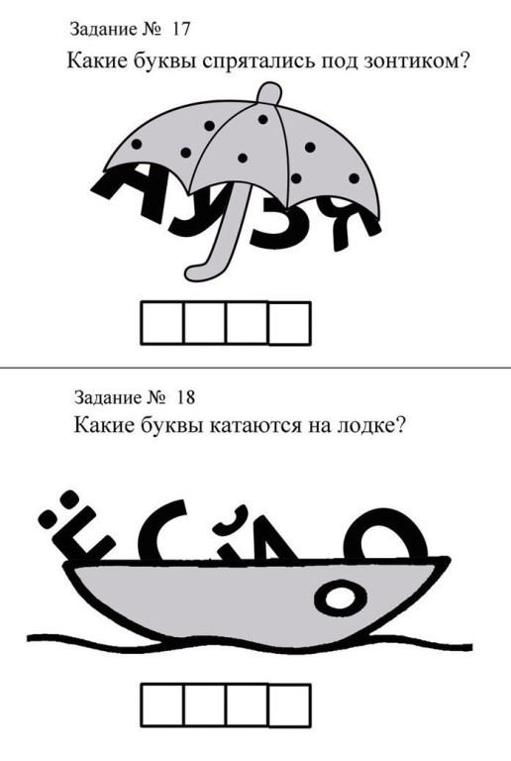](https://ok.ru/dk?cmd=PopLayerPhoto&st.layer.cmd=PopLayerPhotoOuter&st.layer.type=GROUP&st.layer.revNav=off&st.layer.limitedUi=false&st.layer.closeLayers=off&st.layer.sphotoIds=864367573509;864367573765;864367574021;864367574277;864367574533;864367574789;864367575045;864367575301;864367575557;864367575813&st.layer.showNav=on&st.layer.photoAlbumId=53823353978885&st.layer.epm=off&st.layer.photoId=864367575557&st.layer.opl=off&st.layer.navStartPhotoId=864367575557&st.layer.sbd=off&st.cmd=userMain&st._aid=GroupTopicLayer_openPhotoLayer) [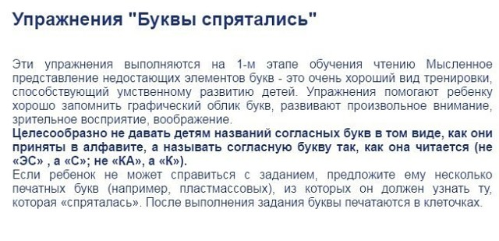](https://ok.ru/dk?cmd=PopLayerPhoto&st.layer.cmd=PopLayerPhotoOuter&st.layer.type=GROUP&st.layer.revNav=off&st.layer.limitedUi=false&st.layer.closeLayers=off&st.layer.sphotoIds=864367573509;864367573765;864367574021;864367574277;864367574533;864367574789;864367575045;864367575301;864367575557;864367575813&st.layer.showNav=on&st.layer.photoAlbumId=53823353978885&st.layer.epm=off&st.layer.photoId=864367575813&st.layer.opl=off&st.layer.navStartPhotoId=864367575813&st.layer.sbd=off&st.cmd=userMain&st._aid=GroupTopicLayer_openPhotoLayer)