Мнемотаблицы.

[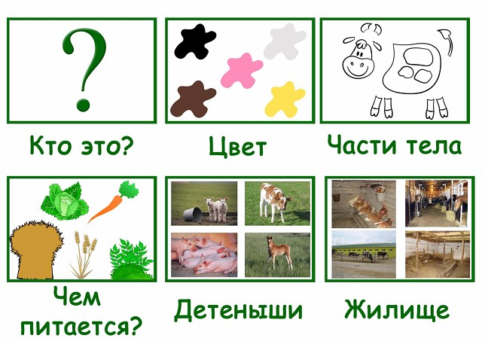](https://ok.ru/dk?cmd=PopLayerPhoto&st.layer.cmd=PopLayerPhotoOuter&st.layer.type=GROUP&st.layer.revNav=off&st.layer.limitedUi=false&st.layer.sphotoIds=838516303621%3B838516303365%3B838516303109%3B838516302853%3B838516302341%3B838516302085%3B838516301829%3B838516301573%3B838516301317%3B838516301061%3B838516300805%3B838516300293%3B838516300037%3B838516299781&st.layer.showNav=on&st.layer.photoAlbumId=53823353978885&st.layer.epm=off&st.layer.photoId=838516303621&st.layer.opl=off&st.layer.navStartPhotoId=838516303621&st.layer.sbd=off&st.cmd=userPage&st._aid=GroupTopicLayer_openPhotoLayer)

[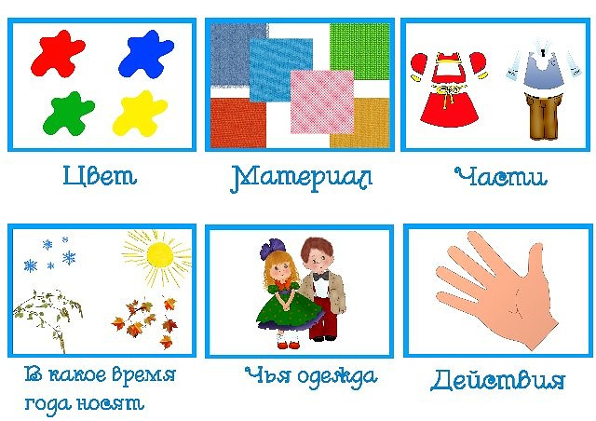](https://ok.ru/dk?cmd=PopLayerPhoto&st.layer.cmd=PopLayerPhotoOuter&st.layer.type=GROUP&st.layer.revNav=off&st.layer.limitedUi=false&st.layer.sphotoIds=838516303621%3B838516303365%3B838516303109%3B838516302853%3B838516302341%3B838516302085%3B838516301829%3B838516301573%3B838516301317%3B838516301061%3B838516300805%3B838516300293%3B838516300037%3B838516299781&st.layer.showNav=on&st.layer.photoAlbumId=53823353978885&st.layer.epm=off&st.layer.photoId=838516303365&st.layer.opl=off&st.layer.navStartPhotoId=838516303365&st.layer.sbd=off&st.cmd=userPage&st._aid=GroupTopicLayer_openPhotoLayer)

[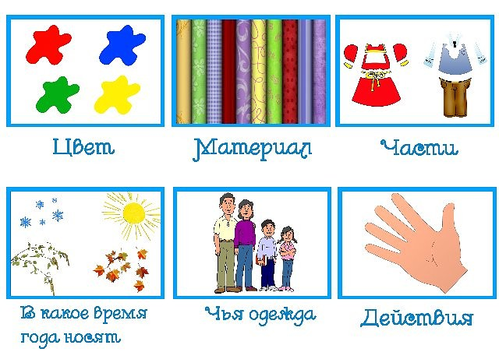](https://ok.ru/dk?cmd=PopLayerPhoto&st.layer.cmd=PopLayerPhotoOuter&st.layer.type=GROUP&st.layer.revNav=off&st.layer.limitedUi=false&st.layer.sphotoIds=838516303621%3B838516303365%3B838516303109%3B838516302853%3B838516302341%3B838516302085%3B838516301829%3B838516301573%3B838516301317%3B838516301061%3B838516300805%3B838516300293%3B838516300037%3B838516299781&st.layer.showNav=on&st.layer.photoAlbumId=53823353978885&st.layer.epm=off&st.layer.photoId=838516303109&st.layer.opl=off&st.layer.navStartPhotoId=838516303109&st.layer.sbd=off&st.cmd=userPage&st._aid=GroupTopicLayer_openPhotoLayer)

[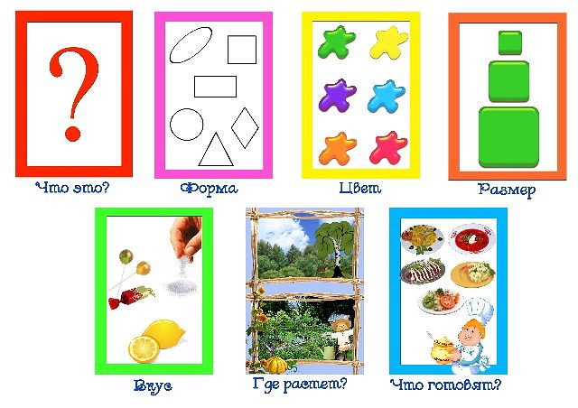](https://ok.ru/dk?cmd=PopLayerPhoto&st.layer.cmd=PopLayerPhotoOuter&st.layer.type=GROUP&st.layer.revNav=off&st.layer.limitedUi=false&st.layer.sphotoIds=838516303621%3B838516303365%3B838516303109%3B838516302853%3B838516302341%3B838516302085%3B838516301829%3B838516301573%3B838516301317%3B838516301061%3B838516300805%3B838516300293%3B838516300037%3B838516299781&st.layer.showNav=on&st.layer.photoAlbumId=53823353978885&st.layer.epm=off&st.layer.photoId=838516302853&st.layer.opl=off&st.layer.navStartPhotoId=838516302853&st.layer.sbd=off&st.cmd=userPage&st._aid=GroupTopicLayer_openPhotoLayer)

[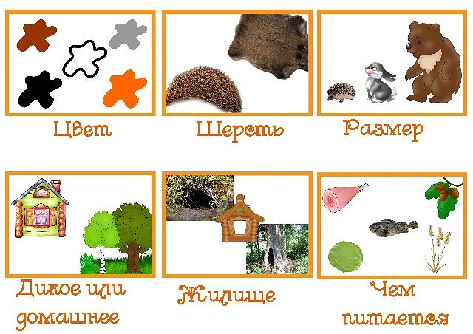](https://ok.ru/dk?cmd=PopLayerPhoto&st.layer.cmd=PopLayerPhotoOuter&st.layer.type=GROUP&st.layer.revNav=off&st.layer.limitedUi=false&st.layer.sphotoIds=838516303621%3B838516303365%3B838516303109%3B838516302853%3B838516302341%3B838516302085%3B838516301829%3B838516301573%3B838516301317%3B838516301061%3B838516300805%3B838516300293%3B838516300037%3B838516299781&st.layer.showNav=on&st.layer.photoAlbumId=53823353978885&st.layer.epm=off&st.layer.photoId=838516302341&st.layer.opl=off&st.layer.navStartPhotoId=838516302341&st.layer.sbd=off&st.cmd=userPage&st._aid=GroupTopicLayer_openPhotoLayer)

[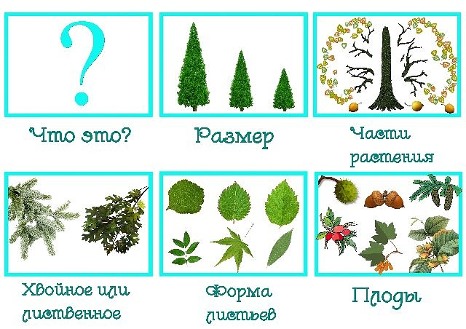](https://ok.ru/dk?cmd=PopLayerPhoto&st.layer.cmd=PopLayerPhotoOuter&st.layer.type=GROUP&st.layer.revNav=off&st.layer.limitedUi=false&st.layer.sphotoIds=838516303621%3B838516303365%3B838516303109%3B838516302853%3B838516302341%3B838516302085%3B838516301829%3B838516301573%3B838516301317%3B838516301061%3B838516300805%3B838516300293%3B838516300037%3B838516299781&st.layer.showNav=on&st.layer.photoAlbumId=53823353978885&st.layer.epm=off&st.layer.photoId=838516302085&st.layer.opl=off&st.layer.navStartPhotoId=838516302085&st.layer.sbd=off&st.cmd=userPage&st._aid=GroupTopicLayer_openPhotoLayer)

[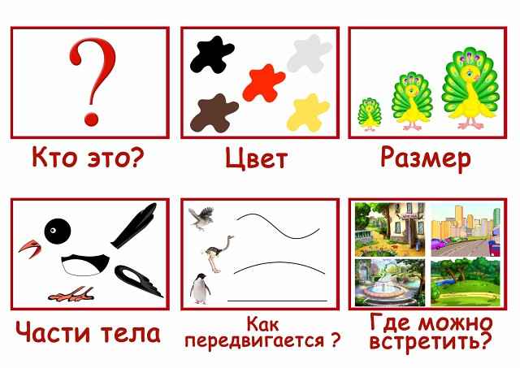](https://ok.ru/dk?cmd=PopLayerPhoto&st.layer.cmd=PopLayerPhotoOuter&st.layer.type=GROUP&st.layer.revNav=off&st.layer.limitedUi=false&st.layer.sphotoIds=838516303621%3B838516303365%3B838516303109%3B838516302853%3B838516302341%3B838516302085%3B838516301829%3B838516301573%3B838516301317%3B838516301061%3B838516300805%3B838516300293%3B838516300037%3B838516299781&st.layer.showNav=on&st.layer.photoAlbumId=53823353978885&st.layer.epm=off&st.layer.photoId=838516301829&st.layer.opl=off&st.layer.navStartPhotoId=838516301829&st.layer.sbd=off&st.cmd=userPage&st._aid=GroupTopicLayer_openPhotoLayer)

[](https://ok.ru/dk?cmd=PopLayerPhoto&st.layer.cmd=PopLayerPhotoOuter&st.layer.type=GROUP&st.layer.revNav=off&st.layer.limitedUi=false&st.layer.sphotoIds=838516303621%3B838516303365%3B838516303109%3B838516302853%3B838516302341%3B838516302085%3B838516301829%3B838516301573%3B838516301317%3B838516301061%3B838516300805%3B838516300293%3B838516300037%3B838516299781&st.layer.showNav=on&st.layer.photoAlbumId=53823353978885&st.layer.epm=off&st.layer.photoId=838516301573&st.layer.opl=off&st.layer.navStartPhotoId=838516301573&st.layer.sbd=off&st.cmd=userPage&st._aid=GroupTopicLayer_openPhotoLayer)

[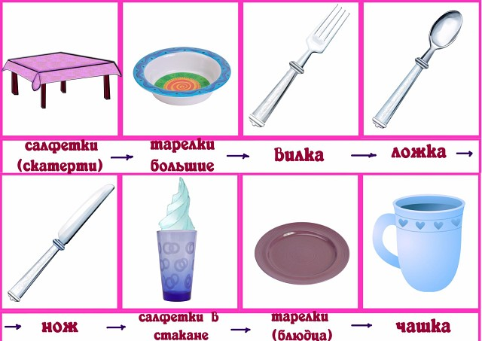](https://ok.ru/dk?cmd=PopLayerPhoto&st.layer.cmd=PopLayerPhotoOuter&st.layer.type=GROUP&st.layer.revNav=off&st.layer.limitedUi=false&st.layer.sphotoIds=838516303621%3B838516303365%3B838516303109%3B838516302853%3B838516302341%3B838516302085%3B838516301829%3B838516301573%3B838516301317%3B838516301061%3B838516300805%3B838516300293%3B838516300037%3B838516299781&st.layer.showNav=on&st.layer.photoAlbumId=53823353978885&st.layer.epm=off&st.layer.photoId=838516301317&st.layer.opl=off&st.layer.navStartPhotoId=838516301317&st.layer.sbd=off&st.cmd=userPage&st._aid=GroupTopicLayer_openPhotoLayer)

[](https://ok.ru/dk?cmd=PopLayerPhoto&st.layer.cmd=PopLayerPhotoOuter&st.layer.type=GROUP&st.layer.revNav=off&st.layer.limitedUi=false&st.layer.sphotoIds=838516303621%3B838516303365%3B838516303109%3B838516302853%3B838516302341%3B838516302085%3B838516301829%3B838516301573%3B838516301317%3B838516301061%3B838516300805%3B838516300293%3B838516300037%3B838516299781&st.layer.showNav=on&st.layer.photoAlbumId=53823353978885&st.layer.epm=off&st.layer.photoId=838516301061&st.layer.opl=off&st.layer.navStartPhotoId=838516301061&st.layer.sbd=off&st.cmd=userPage&st._aid=GroupTopicLayer_openPhotoLayer)

[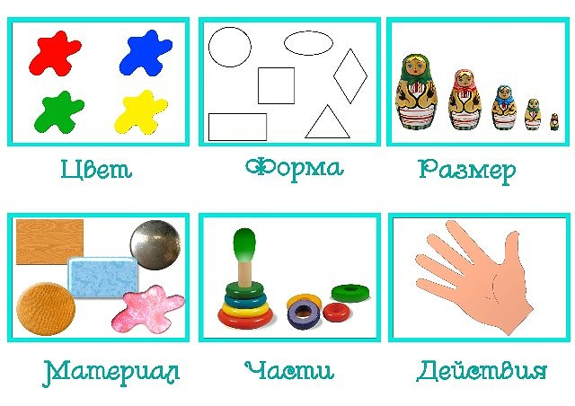](https://ok.ru/dk?cmd=PopLayerPhoto&st.layer.cmd=PopLayerPhotoOuter&st.layer.type=GROUP&st.layer.revNav=off&st.layer.limitedUi=false&st.layer.sphotoIds=838516303621%3B838516303365%3B838516303109%3B838516302853%3B838516302341%3B838516302085%3B838516301829%3B838516301573%3B838516301317%3B838516301061%3B838516300805%3B838516300293%3B838516300037%3B838516299781&st.layer.showNav=on&st.layer.photoAlbumId=53823353978885&st.layer.epm=off&st.layer.photoId=838516300805&st.layer.opl=off&st.layer.navStartPhotoId=838516300805&st.layer.sbd=off&st.cmd=userPage&st._aid=GroupTopicLayer_openPhotoLayer)

[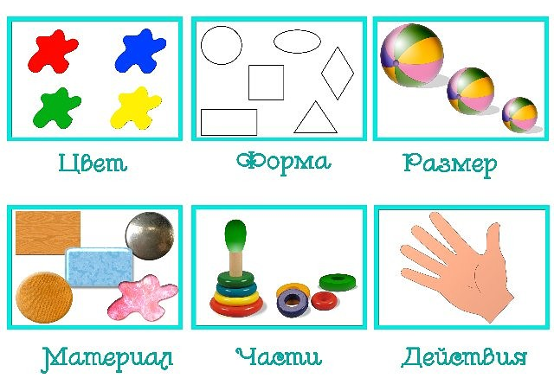](https://ok.ru/dk?cmd=PopLayerPhoto&st.layer.cmd=PopLayerPhotoOuter&st.layer.type=GROUP&st.layer.revNav=off&st.layer.limitedUi=false&st.layer.sphotoIds=838516303621%3B838516303365%3B838516303109%3B838516302853%3B838516302341%3B838516302085%3B838516301829%3B838516301573%3B838516301317%3B838516301061%3B838516300805%3B838516300293%3B838516300037%3B838516299781&st.layer.showNav=on&st.layer.photoAlbumId=53823353978885&st.layer.epm=off&st.layer.photoId=838516300293&st.layer.opl=off&st.layer.navStartPhotoId=838516300293&st.layer.sbd=off&st.cmd=userPage&st._aid=GroupTopicLayer_openPhotoLayer)

[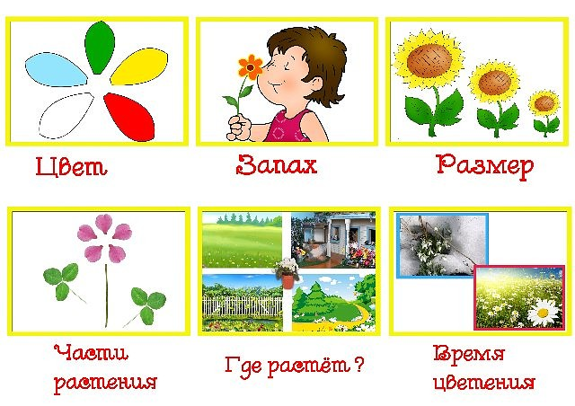](https://ok.ru/dk?cmd=PopLayerPhoto&st.layer.cmd=PopLayerPhotoOuter&st.layer.type=GROUP&st.layer.revNav=off&st.layer.limitedUi=false&st.layer.sphotoIds=838516303621%3B838516303365%3B838516303109%3B838516302853%3B838516302341%3B838516302085%3B838516301829%3B838516301573%3B838516301317%3B838516301061%3B838516300805%3B838516300293%3B838516300037%3B838516299781&st.layer.showNav=on&st.layer.photoAlbumId=53823353978885&st.layer.epm=off&st.layer.photoId=838516300037&st.layer.opl=off&st.layer.navStartPhotoId=838516300037&st.layer.sbd=off&st.cmd=userPage&st._aid=GroupTopicLayer_openPhotoLayer)

[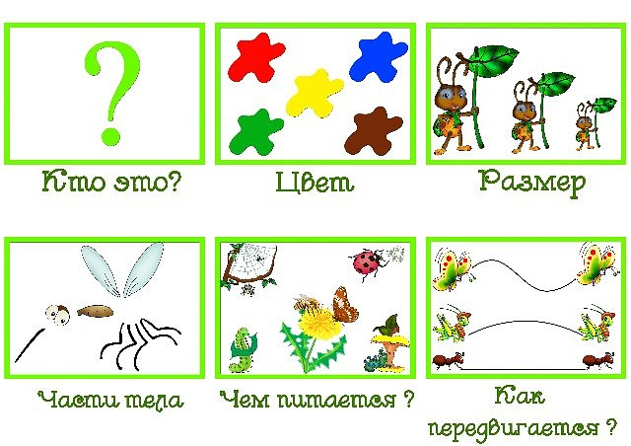](https://ok.ru/dk?cmd=PopLayerPhoto&st.layer.cmd=PopLayerPhotoOuter&st.layer.type=GROUP&st.layer.revNav=off&st.layer.limitedUi=false&st.layer.sphotoIds=838516303621%3B838516303365%3B838516303109%3B838516302853%3B838516302341%3B838516302085%3B838516301829%3B838516301573%3B838516301317%3B838516301061%3B838516300805%3B838516300293%3B838516300037%3B838516299781&st.layer.showNav=on&st.layer.photoAlbumId=53823353978885&st.layer.epm=off&st.layer.photoId=838516299781&st.layer.opl=off&st.layer.navStartPhotoId=838516299781&st.layer.sbd=off&st.cmd=userPage&st._aid=GroupTopicLayer_openPhotoLayer)

Мнемотаблицы для составления рассказов

[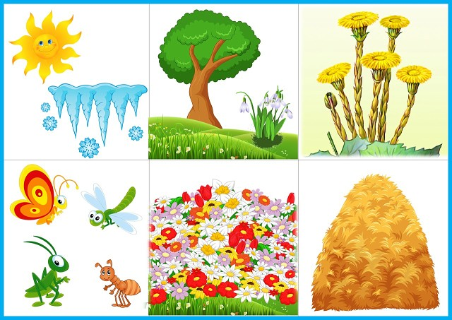](https://ok.ru/dk?cmd=PopLayerPhoto&st.layer.cmd=PopLayerPhotoOuter&st.layer.type=GROUP&st.layer.revNav=off&st.layer.limitedUi=false&st.layer.sphotoIds=838519491589;838519491333;838519491077;838519490821&st.layer.showNav=on&st.layer.photoAlbumId=53823353978885&st.layer.epm=off&st.layer.photoId=838519491589&st.layer.opl=off&st.layer.navStartPhotoId=838519491589&st.layer.sbd=off&st.cmd=userPage&st._aid=GroupTopicLayer_openPhotoLayer)

[](https://ok.ru/dk?cmd=PopLayerPhoto&st.layer.cmd=PopLayerPhotoOuter&st.layer.type=GROUP&st.layer.revNav=off&st.layer.limitedUi=false&st.layer.sphotoIds=838519491589;838519491333;838519491077;838519490821&st.layer.showNav=on&st.layer.photoAlbumId=53823353978885&st.layer.epm=off&st.layer.photoId=838519491333&st.layer.opl=off&st.layer.navStartPhotoId=838519491333&st.layer.sbd=off&st.cmd=userPage&st._aid=GroupTopicLayer_openPhotoLayer)

[](https://ok.ru/dk?cmd=PopLayerPhoto&st.layer.cmd=PopLayerPhotoOuter&st.layer.type=GROUP&st.layer.revNav=off&st.layer.limitedUi=false&st.layer.sphotoIds=838519491589;838519491333;838519491077;838519490821&st.layer.showNav=on&st.layer.photoAlbumId=53823353978885&st.layer.epm=off&st.layer.photoId=838519491077&st.layer.opl=off&st.layer.navStartPhotoId=838519491077&st.layer.sbd=off&st.cmd=userPage&st._aid=GroupTopicLayer_openPhotoLayer)

[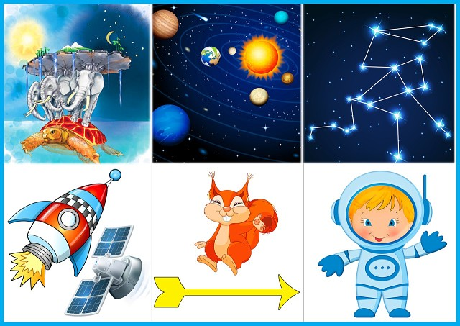](https://ok.ru/dk?cmd=PopLayerPhoto&st.layer.cmd=PopLayerPhotoOuter&st.layer.type=GROUP&st.layer.revNav=off&st.layer.limitedUi=false&st.layer.sphotoIds=838519491589;838519491333;838519491077;838519490821&st.layer.showNav=on&st.layer.photoAlbumId=53823353978885&st.layer.epm=off&st.layer.photoId=838519490821&st.layer.opl=off&st.layer.navStartPhotoId=838519490821&st.layer.sbd=off&st.cmd=userPage&st._aid=GroupTopicLayer_openPhotoLayer)